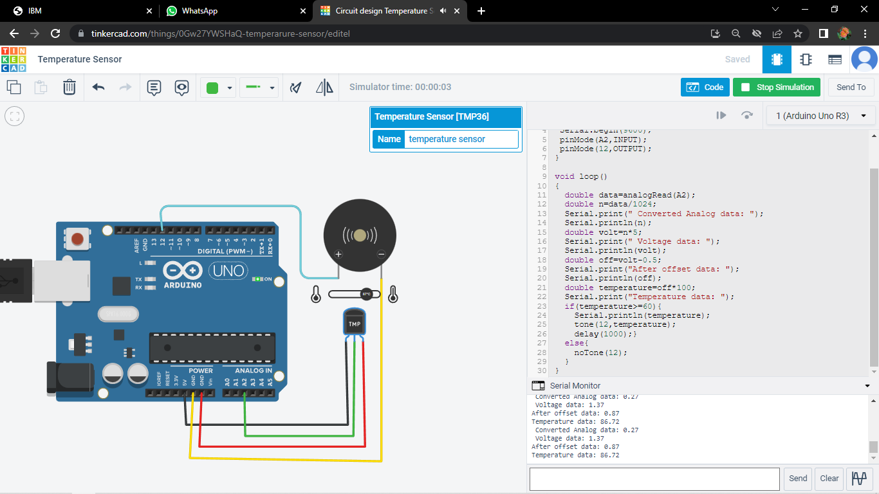

<https://www.tinkercad.com/things/0Gw27YWSHaQ-temperarure-sensor/editel>

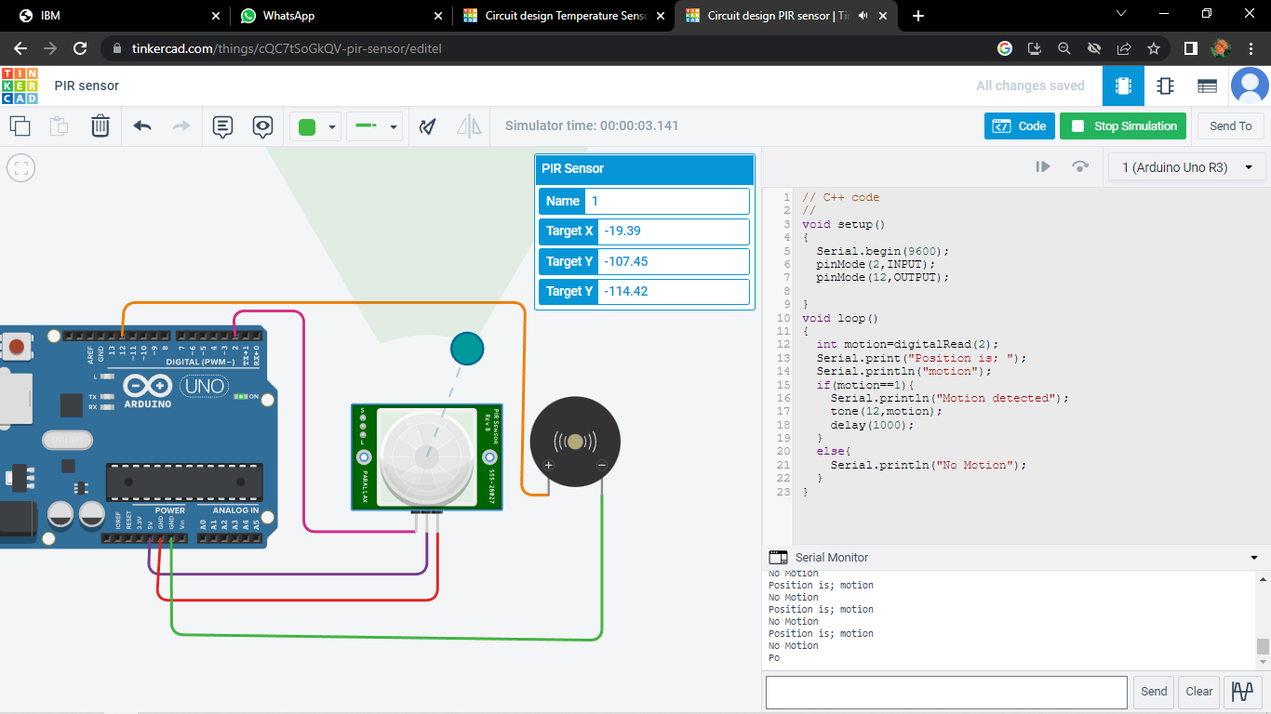

<https://www.tinkercad.com/things/cQC7tSoGkQV-pir-sensor/editel>